**ASSIGNMENT 1**

create a **Work Breakdown Structure (WBS)** for an online shopping website.

On this website, customers would be able to browse and search for products. They can add products to a shopping cart and purchase items in the shopping cart. There are advertisements on the website which are purchased by external companies to advertise their product or service. These appear down the side of the website. Some banners display deals or discounts to the shopper. These appear front and center, and only display deals for the online shopping website.

Your task is to Create a **Work Breakdown Structure (WBS)** for this product that is at least **three (3) tiers**. Make sure that work products on the WBS are broken down to appropriate sizes. Include all the features described in this assignment. You may also add other features or work products that you feel would be relevant to the product.

Discount Banner

Product View

Advertisement

Banners

Checkout

Purchase

Items

Product List

Shopping

Product

Internal Discount Display Logic

External Ad Integration

Add Product

Search

Handle Purchase

Checkout Process

Add to cart logic

Search

Browse

Advertising

Shopping

Product

Security

Performance

System

Checkout Flow

Add to Cart

Functionality

Deployment Guide

API

FAQ’S

User Manual

System Design

Technical

User

DOCUMENTATION

TEST

CODE

DESIGN

ONLINE SHOPPING

**ASSIGNMENT 2**

This assignment will challenge you (the Product Owner) to organize a set of user stories into a series of sprints that will comprise a release plan for personal development software product:

Your developers are going to build a health monitoring application that will allow football players and their trainers to track various aspects of their health.

Football players will be able to:

* track the meals they eat,
* their water consumption,
* their physical activity,
* their goals, and
* their weight

Trainers will be able to view the information that their football players enter.

The user will enter personal information such as:

* height,
* current weight, and
* target weight.

Your task is to identify at least 10 dependencies and then generate a release plan with four (4) sprints based on the prioritized release backlog. You are allowed to place any unassigned user stories in a Product backlog.

For the past two projects, your developers have completed 20 story points per sprint. Use this value as the maximum amount of story points per sprint.

**IDENTIFIED DEPENDENCIES:**

* User ID #4 depends on User ID #1, #2 & #3
* User ID #6 depends on User ID #1 & #5
* User ID #7 depends on User ID #5
* User ID #10 depends on User ID #1 & #8
* User ID #11 depends on User ID #9 & #10
* User ID #13 depends on User ID #1
* User ID #17 depends on User ID #1
* User ID #18 depends on User ID #16
* User ID #24 depends on User ID #15 (Trainer needs player's fitness goals)
* User ID #25 depends on User ID #16 (Trainer needs player's dietary goals)

**SPRINT 1**

This sprint focuses on establishing the core personal tracking features for the football player and the initial trainer linkage.

|  |  |  |  |  |
| --- | --- | --- | --- | --- |
| **USER ID** | **USER STORY** | **PRIORITY** | **RISK** | **POINTS** |
| 5 | As a football player, I want to enter the exercise that I do, so that I can track my activity. | Must Do | High | 8 |
| 19 | As a football player, I want to link a trainer to my account, so they can track my progress | Must Do | High | 8 |
| 1 | As a football player, I want to enter weight and height information, so that I can use that information to track and calculate other health information. | Must Do | Low | 3 |
| **Total** |  |  |  | **19** |

**SPRINT 2**

This sprint builds on the initial data entry, allowing players to track meals and setting up trainer visibility for core activities and nutrition.

|  |  |  |  |  |
| --- | --- | --- | --- | --- |
| **USER ID** | **USER STORY** | **PRIORITY** | **RISK** | **POINTS** |
| 8 | As a football player, I want to be able to enter what I eat for each meal, so that I can track my nutrition. | Must Do | Moderate | 5 |
| 21 | As a trainer, I want to see the amount of exercise that my athletes are completing, so that I can see how much they are exercising | Must Do | Moderate | 5 |
| 22 | As a trainer, I want to see what my athletes are eating, so that I can determine if their diet is appropriate for their training | Must Do | Moderate | 5 |
| 2 | As a football player, I want the application to track my weight so that I can see my improvements. | Must Do | Low | 5 |
| **Total** |  |  |  | **20** |

**SPRINT 3**

This sprint focuses on goal setting for players and the associated trainer visibility, along with hydration tracking.

|  |  |  |  |  |
| --- | --- | --- | --- | --- |
| **USER ID** | **USER STORY** | **PRIORITY** | **RISK** | **POINTS** |
| 15 | As a football player, I want to enter fitness goals, so that I have a goal to obtain. | Must Do | Moderate | 2 |
| 16 | As a football player, I want to enter dietary goals, so that I have a goal to obtain. | Must Do | Moderate | 2 |
| 20 | As a trainer, I want to see the height and weight information of my football players, so that I can adjust their trainings and diets appropriately | Must Do | Moderate | 5 |
| 12 | As a football player, I want to enter the amount of water I consume, so that I can track my hydration. | Should Do | Moderate | 3 |
| 24 | As a trainer, I want to see the fitness goals of my football players, so that I can adjust their trainings to meet their goals | Should Do | Low | 3 |
| 25 | As a trainer, I want to see the dietary goals of my football players, so that I can adjust their diet to meet their goals | Should Do | Low | 3 |
| **Total** |  |  |  | **18** |

**SPRINT 4**

The final sprint focuses on notifications, suggested calculations, and more detailed caloric intake tracking.

|  |  |  |  |  |
| --- | --- | --- | --- | --- |
| **USER ID** | **USER STORY** | **PRIORITY** | **RISK** | **POINTS** |
| 7 | As a football player, I want the application to notify me if I am not exercising frequently enough so that I stay in shape. | Should Do | Moderate | 3 |
| 17 | As a football player, I want the application to notify me if I am not meeting my fitness goals so that I can stay on track to meeting my goals. | Should Do | Moderate | 3 |
| 18 | As a football player, I want the application to notify me if I am not meeting my dietary goals so that I can stay on track to meeting my goals. | Should Do | Moderate | 3 |
| 9 | As a football player, I want to enter the calories for the food I eat, so that I know how much I am consuming. | Should Do | Moderate | 2 |
| 3 | As a football player, I want to set a target weight, so that I have a weight goal to reach. | Should Do | Low | 1 |
| 13 | As a football player, I want the application to calculate a suggested amount of water that I should consume based on my height and weight so that I am accurately hydrating. | Could Do | High | 2 |
| 4 | As a football player, I want the application to calculate how many pounds per week I should lose so that I can see if I'm on track with my weight goals. | Could Do | Moderate | 2 |
| 11 | As a football player, I want the application to notify me if I am not meeting my suggested calorie intake so that I am following my diet accurately. | Could Do | Moderate | 2 |
| **Total** |  |  |  | **18** |

**RETURNED TO BACKLOG**

These stories will be considered for future releases after the initial four sprints are complete.

|  |  |  |  |  |
| --- | --- | --- | --- | --- |
| **USER ID** | **USER STORY** | **PRIORITY** | **RISK** | **POINTS** |
| 14 | As a football player, I want the application to notify me to remind me to drink water so that I am constantly hydrating. | Could Do | Moderate | 3 |
| 6 | As a football player, I want the application to calculate the amount of calories burned in a workout based on the activity and my body size so that I know the results of my workout. | Could Do | Low | 5 |
| 10 | As a football player, I want the application to calculate a suggested amount of calories for each meal based on my height and weight, so I can adjust my diet accordingly. | Could Do | Low | 3 |
| 23 | As a trainer, I want to see how much water my football players are drinking, so that I can make sure they are hydrating appropriately | Could Do | Moderate | 5 |
| **Total** |  |  |  | **16** |

**ASSIGNMENT 3**

In this assignment, take the following work breakdown structure and organize it into a CPM Chart.

The estimated time, is measured in days, and they appear in the boxes in the bottom right corner of each task.

For the purpose of having dependencies,

* The design for a feature must be complete before programming for that feature can occur.
* The feature design must also be complete before the user manual can be written for that feature.
* You must program the home page, before you program the search bar.
* The programming for the search bar and homepage does not need to be completed before you connect the database to the application (these can be done in parallel).
* The programming for a feature must be complete AND the database must be connected to the application before you can execute acceptance tests.
* The programming for the database must be complete before you can connect the database to the application.
* You can test the database after the database is connected to the application.
* For simplicity, you can combine all the acceptance tests tasks to one line named “Execute Acceptance Tests on All Pages” that takes 1 day to complete.

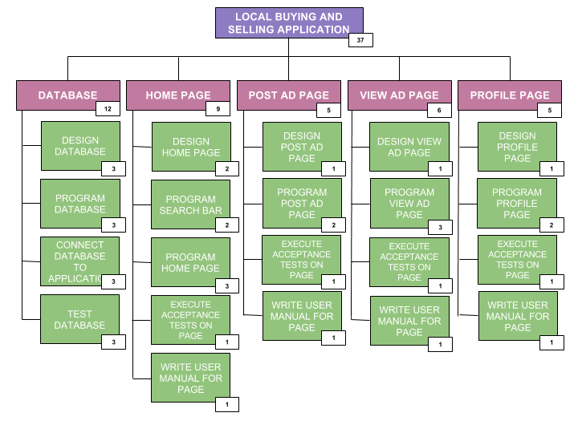

**CPM CHART**

Critical path

FINISH

ACCEPTANCE TEST

PROGRAM PROFILE PAGE

DESIGN PROFILE PAGE

PROGRAM VIEW AD PAGE

DESIGN VIEW AD PAGE

DESIGN POST AD PAGE

PROGRAM POST AD PAGE

PROGRAM SEARCH BAR

PROGRAM HOME PAGE

WRITE USER MANUAL

DESIGN HOME PAGE

DATABASE DESIGN

TEST DATABASE

CONNECT DB TO APPLICATION

PROGRAM DATABASE

START